EXPLORATORY DATA ANALYSIS REPORT

Date: February 06.02. 2026
Kairzhan Tomiris

1. EXECUTIVE SUMMARY
Dataset Overview: This analysis examines 1,000 student records across 8 features including demographic information, parental education, socioeconomic indicators, and academic scores in mathematics, reading, and writing.

Key Findings:
• Gender Performance Gap: Males score 5.1 points higher in mathematics (68.7 vs 63.6), representing an 8% performance advantage.
• Test Preparation Impact: Students who completed test preparation courses score 7.6 points higher on average (72.7 vs 65.0), demonstrating an 11.7% improvement.
• Socioeconomic Influence: Students with standard lunch status outperform those with free/reduced lunch by 8.6 points (70.8 vs 62.2), indicating a 13.9% achievement gap correlated with economic status.

2. DATA QUALITY
Missing Values: No missing values detected across all 8 columns. Dataset is complete with 100% data coverage.
Data Types: All data types are appropriate - categorical variables (gender, race/ethnicity, parental education, lunch type, test preparation) stored as objects; numerical scores stored as int64.
Outliers: Score ranges are valid (0-100). Some low scores exist but appear legitimate rather than data errors. One student with math score of 0 may warrant investigation.
Data Integrity: No duplicate records found. All categorical values are consistent and properly formatted.

3. KEY INSIGHTS

Insight 1: Significant Gender Gap in Mathematics
Supporting Evidence:
• Male students average 68.73 in mathematics
• Female students average 63.63 in mathematics
• Difference of 5.10 points represents an 8.0% performance gap
• This gap is notably larger in math compared to reading and writing subjects
Implications: This finding suggests potential biases in math education or societal expectations that may discourage female students. Targeted interventions and mentoring programs for female students in mathematics could help close this gap.

Insight 2: Test Preparation Courses Are Highly Effective
Supporting Evidence:
• Students with test prep average 72.67 across all subjects
• Students without test prep average 65.04 across all subjects
• Improvement of 7.63 points represents 11.7% higher performance
• Benefits are consistent across math, reading, and writing
Implications: Test preparation courses demonstrate clear value. Schools should consider making these courses more widely available, particularly for students from disadvantaged backgrounds who may not have access to private tutoring.

Insight 3: Strong Correlation Between Economic Status and Performance
Supporting Evidence:
• Students with standard lunch average 70.84 points
• Students with free/reduced lunch average 62.20 points
• Gap of 8.64 points represents 13.9% performance difference
• This is the largest performance gap among all factors analyzed
Implications: Socioeconomic status significantly impacts academic achievement. This suggests the need for additional support resources, tutoring programs, and equitable access to educational materials for economically disadvantaged students.

4. LAB QUESTIONS - ANSWERS

Question 1: What's the average math score by gender?
Gender | Average Math Score
Male | 68.73
Female | 63.63
Answer: Male students have an average math score of 68.73, while female students average 63.63, showing a 5.10-point difference in favor of males.

Question 2: Is there correlation between reading and writing scores?
Answer: Yes, there is a very strong positive correlation of 0.9546 between reading and writing scores. This indicates that students who perform well in reading almost always perform well in writing, and vice versa. This near-perfect correlation (approaching 1.0) suggests these skills are highly interconnected and likely develop together.
Statistical Interpretation: A correlation coefficient of 0.95 means that approximately 91% of the variance in writing scores can be explained by reading scores. This is considered an extremely strong relationship in educational research.

Question 3: Do test preparation courses help?
Test Prep Status | Average Score | Difference
Completed | 72.67 | +7.63 points
None | 65.04 | —
Answer: Yes, test preparation courses significantly help student performance. Students who completed test prep courses score 7.63 points higher on average (an 11.7% improvement). This improvement is consistent across all three subjects (math, reading, and writing).

Question 4: Which parental education level gives best results?
Parental Education Level | Average Score
Master's degree | 73.60
Bachelor's degree | 71.92
Associate's degree | 69.57
Some college | 68.48
Some high school | 65.11
High school | 63.10
Answer: Students whose parents have a master's degree achieve the highest average scores (73.60). There is a clear positive correlation between parental education level and student performance, with scores declining progressively as parental education decreases. The gap between master's degree and high school is 10.5 points (16.7% difference).

Question 5: What's the score distribution by lunch type?
Lunch Type | Math | Reading | Writing
Standard | 70.03 | 71.65 | 70.82
Free/Reduced | 58.92 | 64.65 | 63.02
Answer: Students with standard lunch status consistently outperform those with free/reduced lunch across all subjects. The gaps are: Math (11.1 points), Reading (7.0 points), and Writing (7.8 points). The average overall difference is 8.6 points, representing a 13.9% performance gap. This suggests that socioeconomic status (as indicated by lunch type) is a significant predictor of academic achievement.

5. VISUALIZATION SUMMARY

Chart 1: Score Distribution by Gender
This boxplot visualization shows the distribution of scores across all three subjects (Math, Reading, Writing) separated by gender. The visualization reveals that males show higher median scores in mathematics, while the distributions are more similar in reading and writing. The presence of outliers (low scores) is visible across all categories.
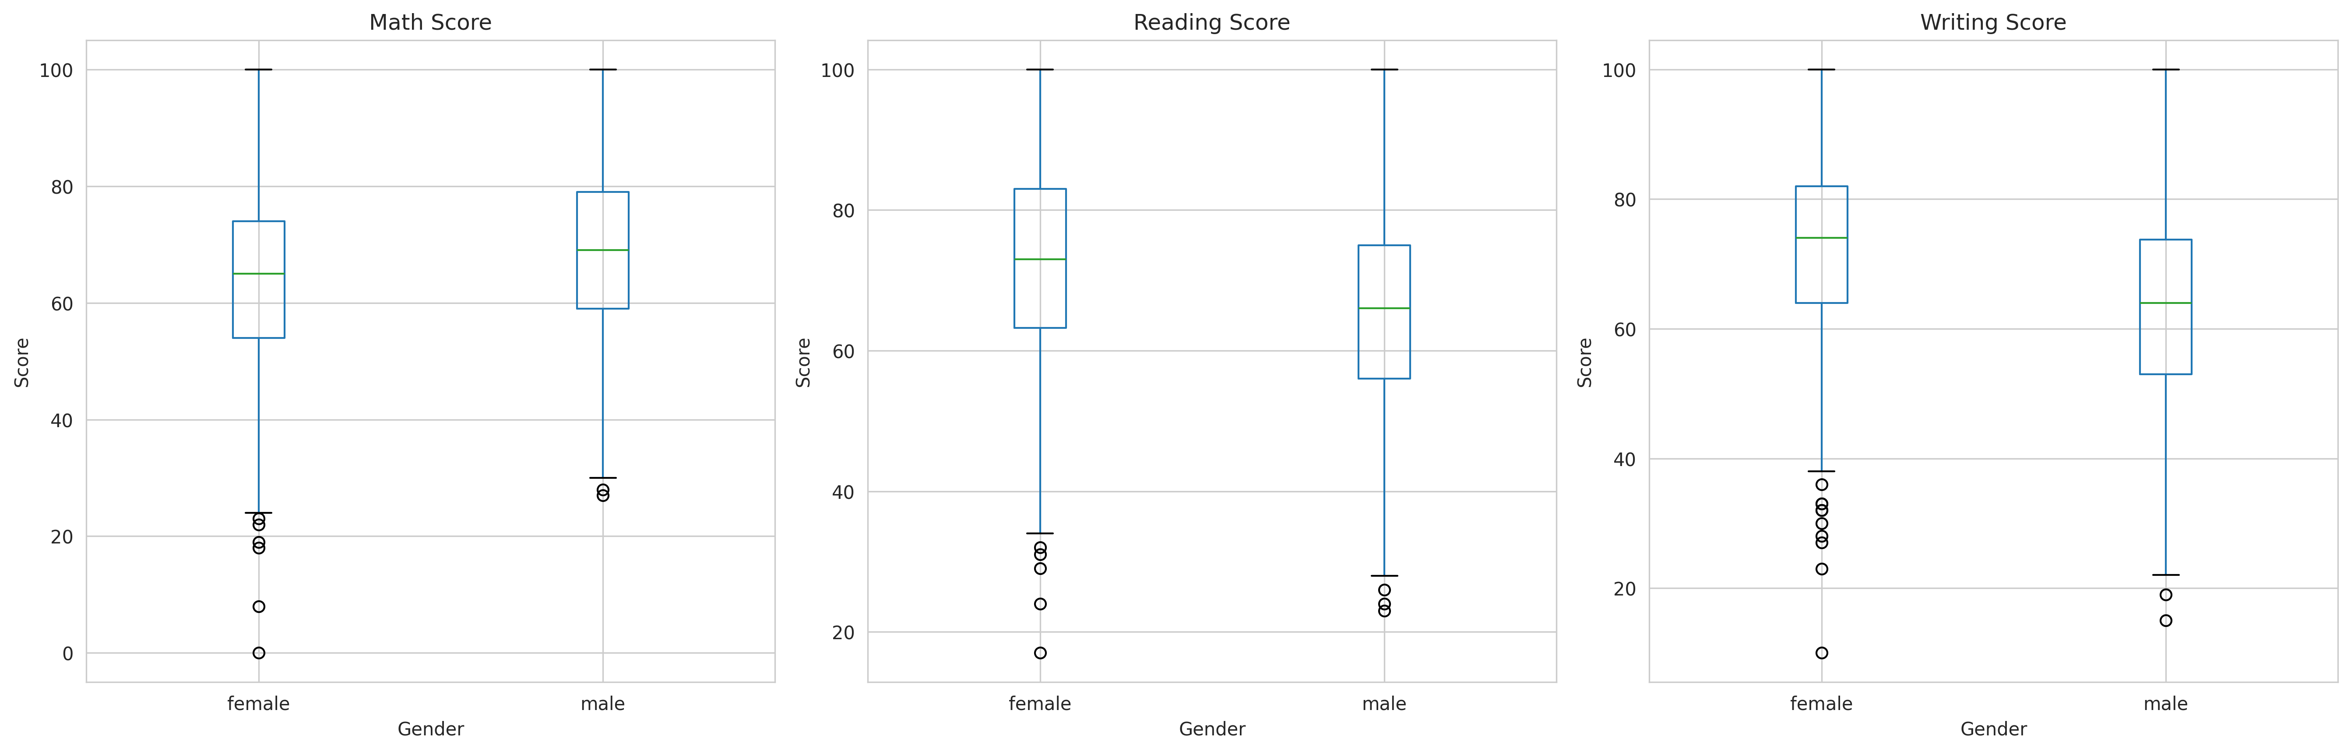

Chart 2: Reading vs Writing Score Correlation
This scatter plot demonstrates the extremely strong positive correlation (r = 0.9546) between reading and writing scores. Points colored by gender (blue for males, red for females) cluster tightly along the regression line, indicating that students who excel in reading almost invariably excel in writing. This suggests these literacy skills are highly interconnected and likely develop in tandem.
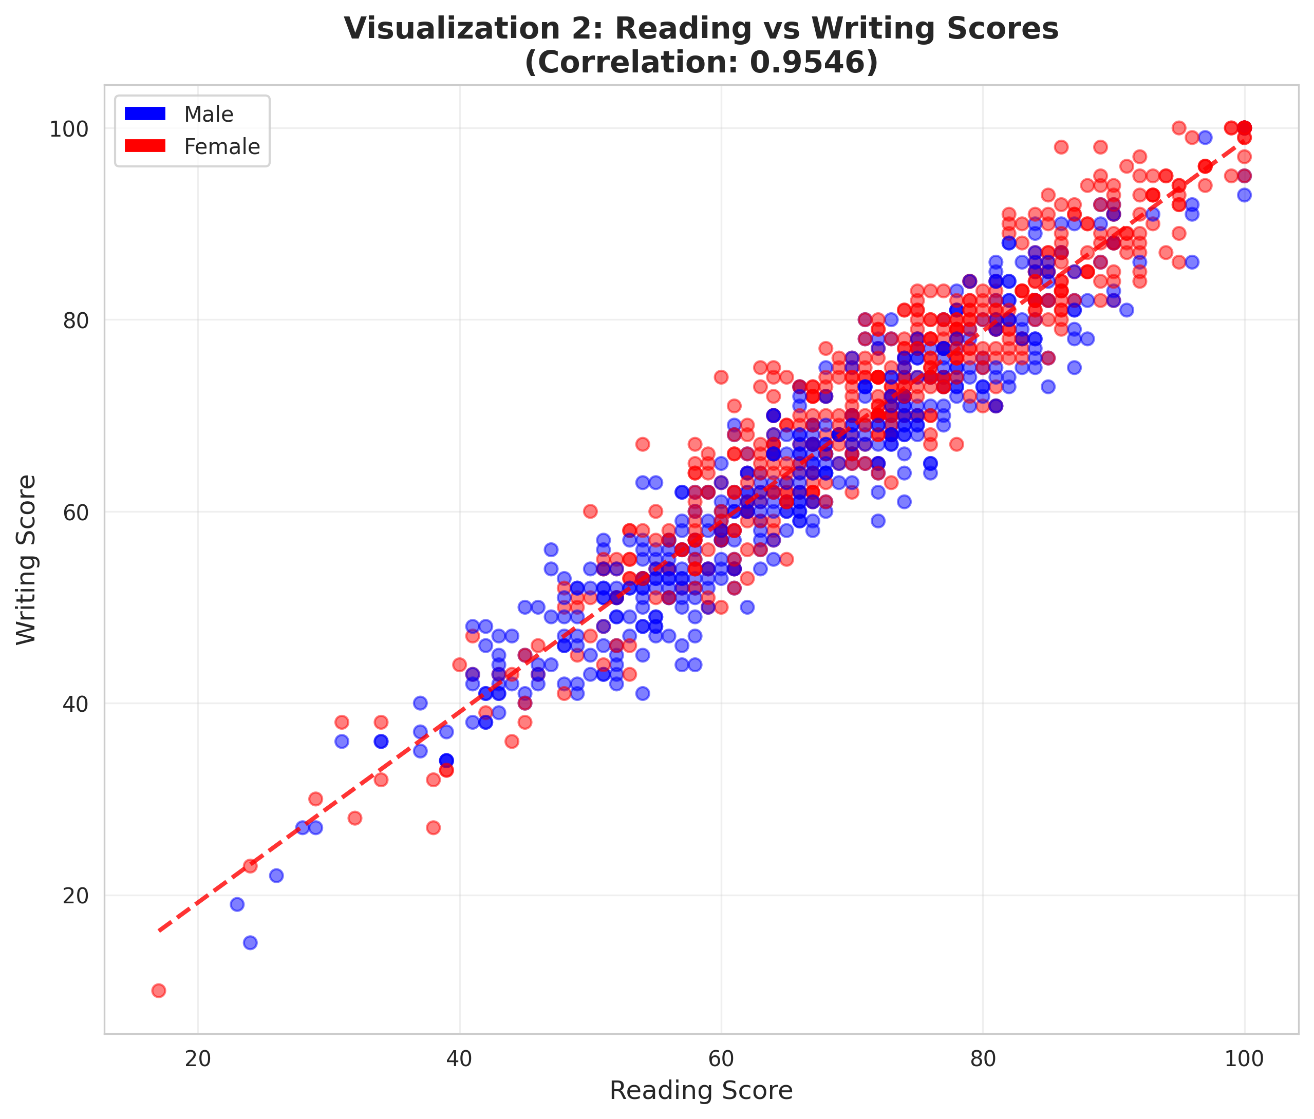

Chart 3: Comprehensive Factors Affecting Performance
This multi-panel visualization provides a comprehensive view of various factors affecting student performance:
• Top Left: Test preparation impact shows consistent improvement across all subjects for students who completed the course.
• Top Right: Parental education level demonstrates a clear positive correlation with student achievement.
• Bottom Left: Lunch type reveals the significant impact of socioeconomic status on performance.
• Bottom Right: The distribution histogram shows overall scores are approximately normally distributed with a mean of 67.77 and median of 68.33.
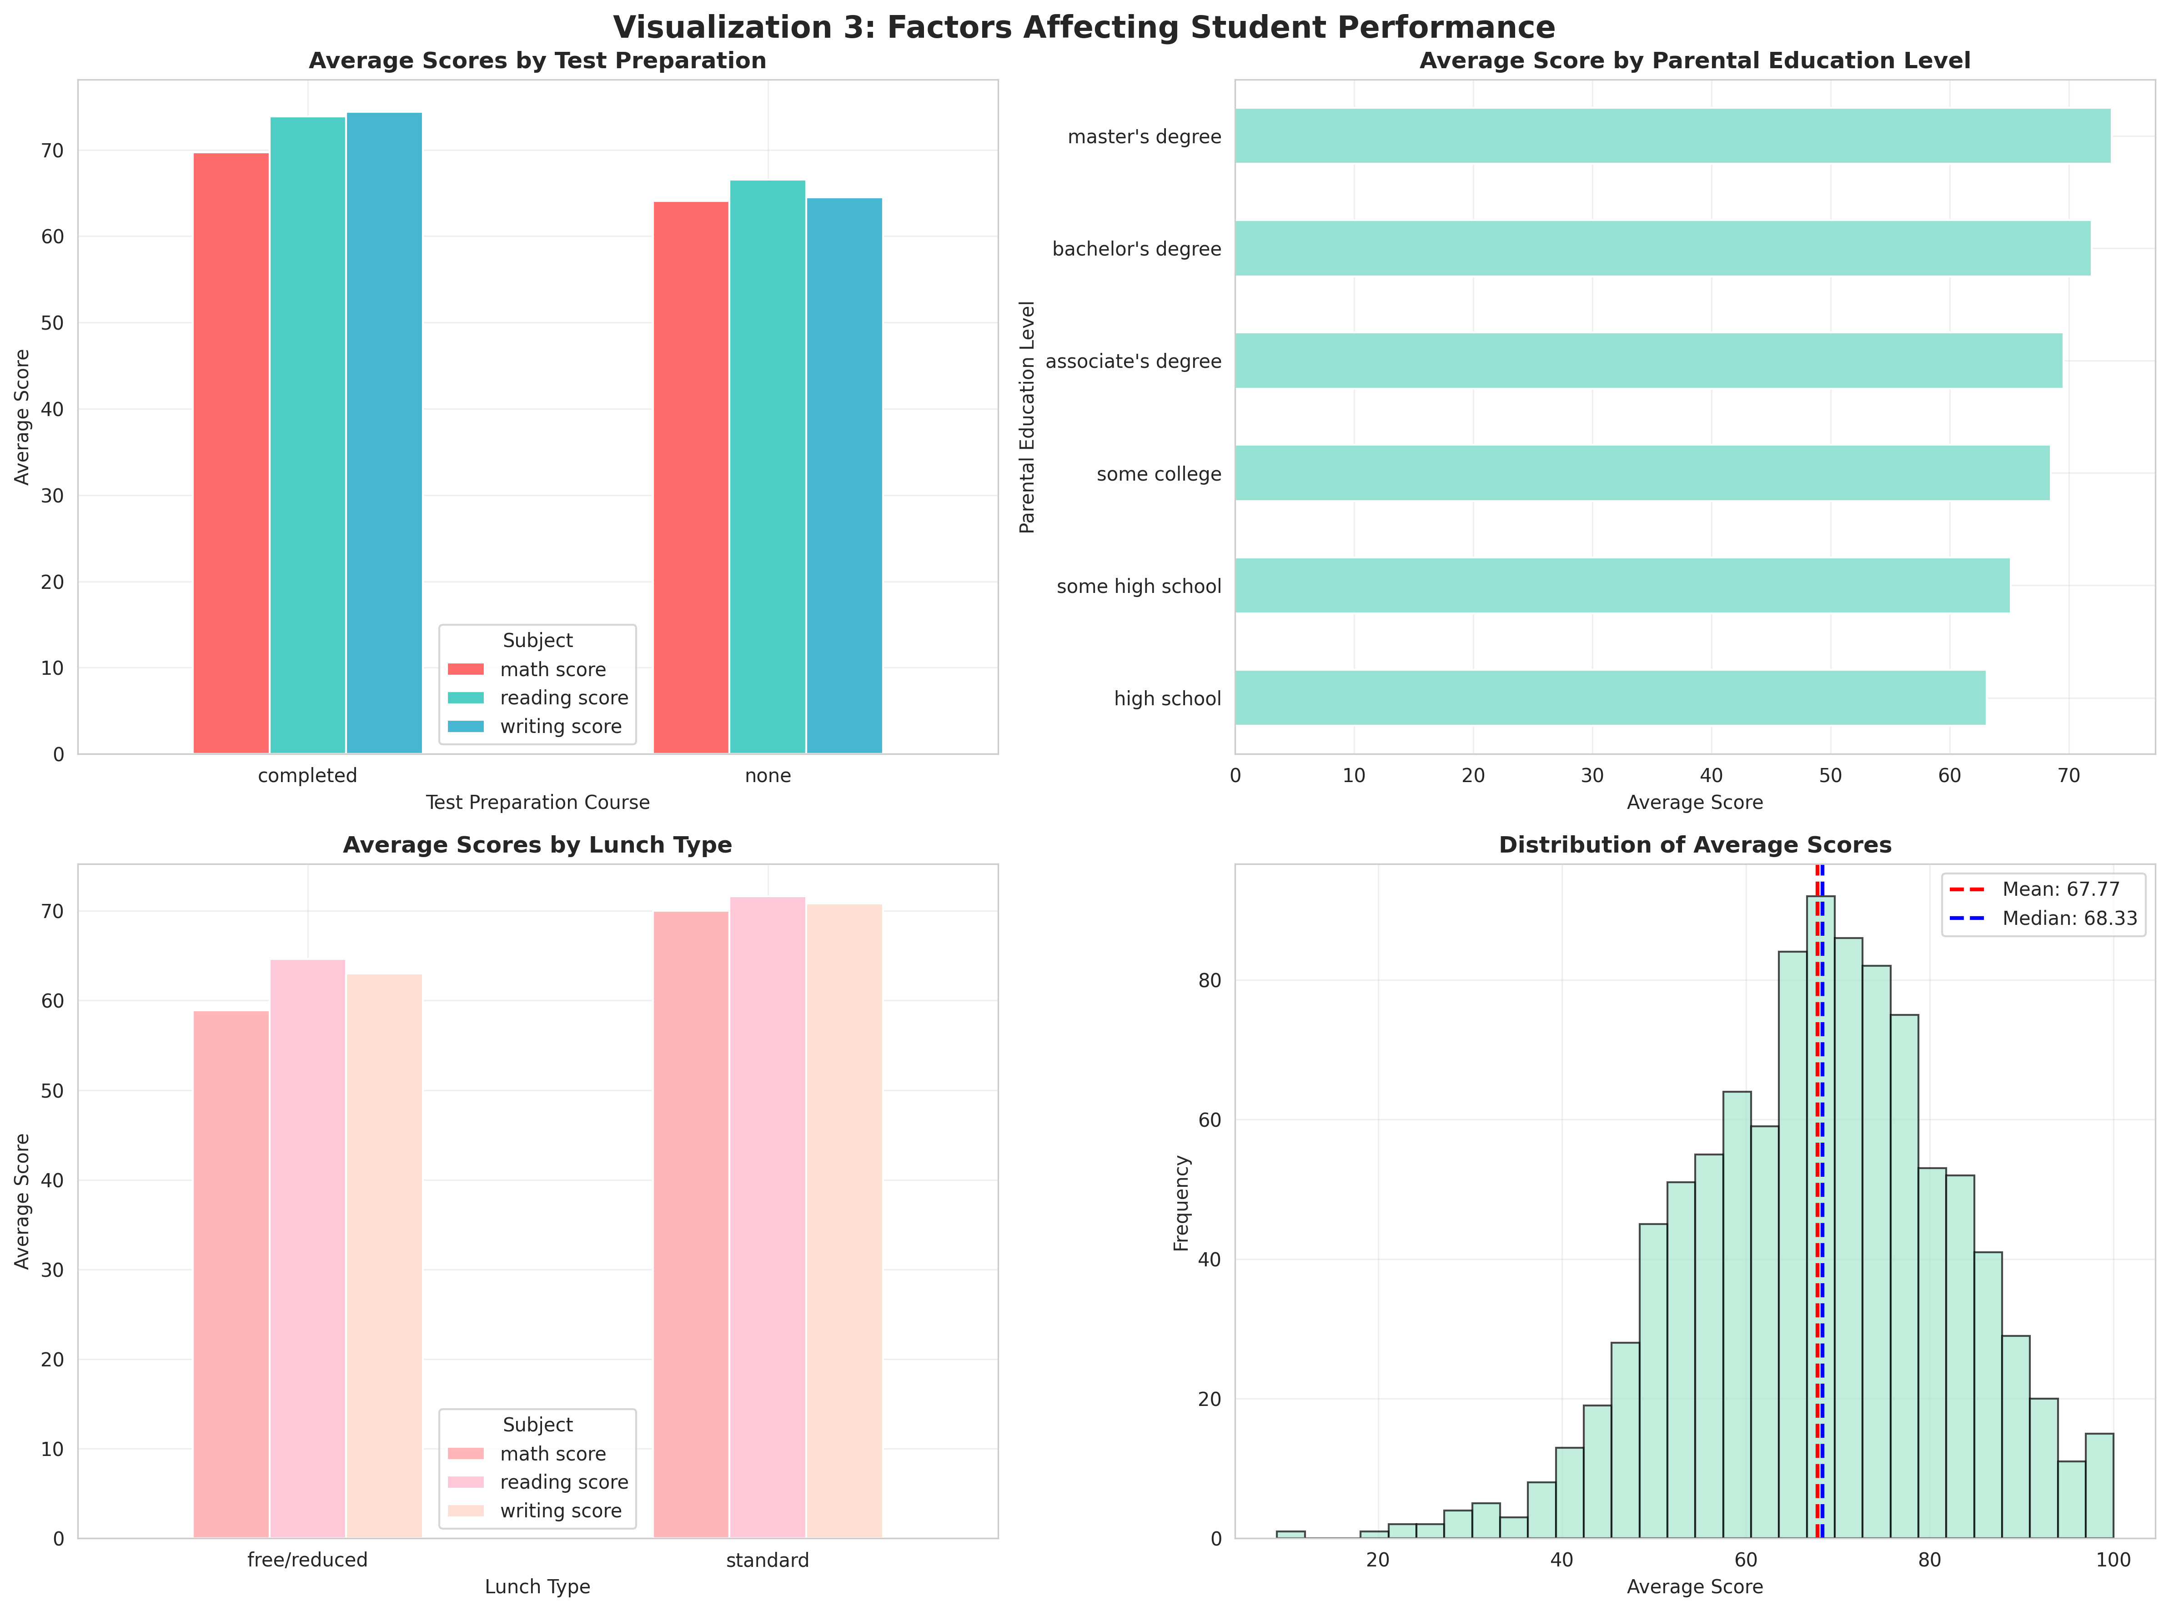

6. RECOMMENDATIONS

Next Analysis Steps:
• Conduct multivariate analysis to understand interaction effects between variables (e.g., does test prep impact vary by socioeconomic status?)
• Investigate the specific student with math score of 0 to determine if this is a data entry error or represents a legitimate case requiring intervention
• Perform longitudinal analysis if additional data becomes available to track performance trends over time

Data Collection Improvements:
• Add variables tracking hours of study time to better understand effort-performance relationships
• Include information about school quality, teacher experience, and class sizes to account for institutional factors
• Collect data on extracurricular activities and their correlation with academic performance

Business/Educational Implications:
Expand Test Preparation Programs: Given the 11.7% improvement associated with test prep, schools should prioritize making these courses widely accessible, particularly for economically disadvantaged students who show the largest achievement gaps.
Address Gender Gap in Math: Implement targeted interventions such as female-focused STEM mentoring programs, review curriculum for implicit bias, and create supportive learning environments that encourage female participation in mathematics.
Support Economically Disadvantaged Students: The 13.9% performance gap associated with lunch type indicates a need for comprehensive support programs including free tutoring, after-school programs, access to educational materials, and mentorship opportunities for students from lower-income families.
Leverage Reading-Writing Connection: The extremely high correlation (0.95) between reading and writing scores suggests that integrated literacy programs focusing on both skills simultaneously may be more effective than teaching them separately.
Parental Engagement Programs: While parental education level cannot be changed, schools can develop programs to help all parents support their children's education more effectively, potentially mitigating some of the educational achievement gap.

